Feature selection:

bias/variance

regression Lasso -penalizes extra features -just assigns 0 coefficient to features

SelectPercentile and SelectKBest will give us the features plus TfIdf Vectorizer

tools/email_reprocess.py does feature seleciton......

Parmeter Tuning: GridCV -- finds params for classifiers almost automatically

Principal Components Analysis:

- find new coordinate system - only by move and rotation

- brings down dimensionality of features by creating composite features

- exrmely useful for UNSUPERVISED learning

- principal component - direction of maximum variance (mathematical variance)

- the reason it is like that is becuase it minimizes information loss -

Remember: continuos things -- regression

non-continuos – depends

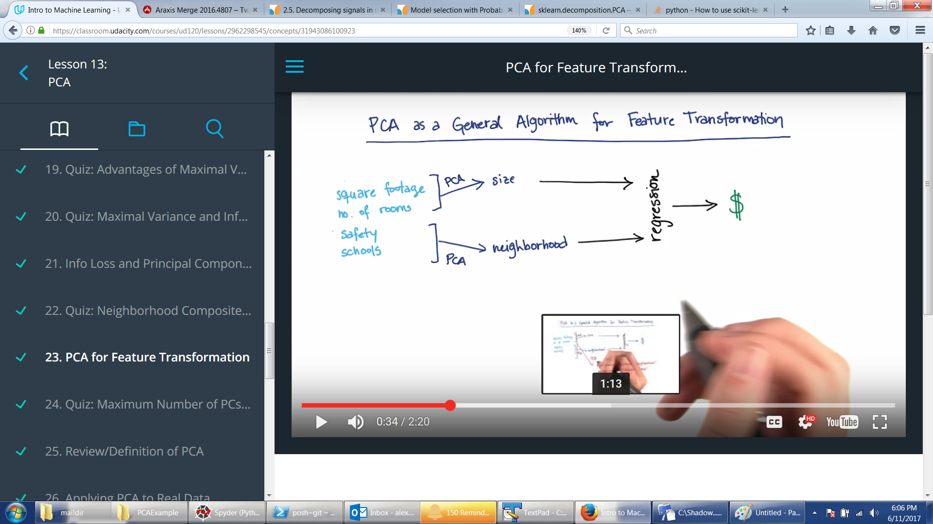

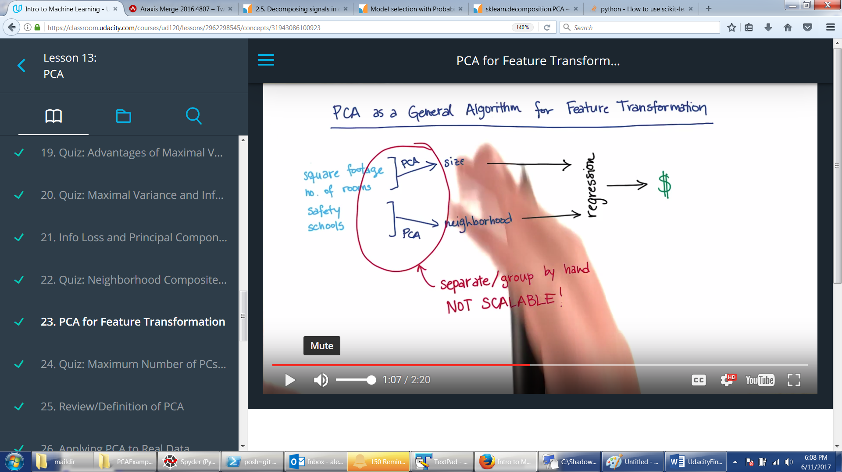

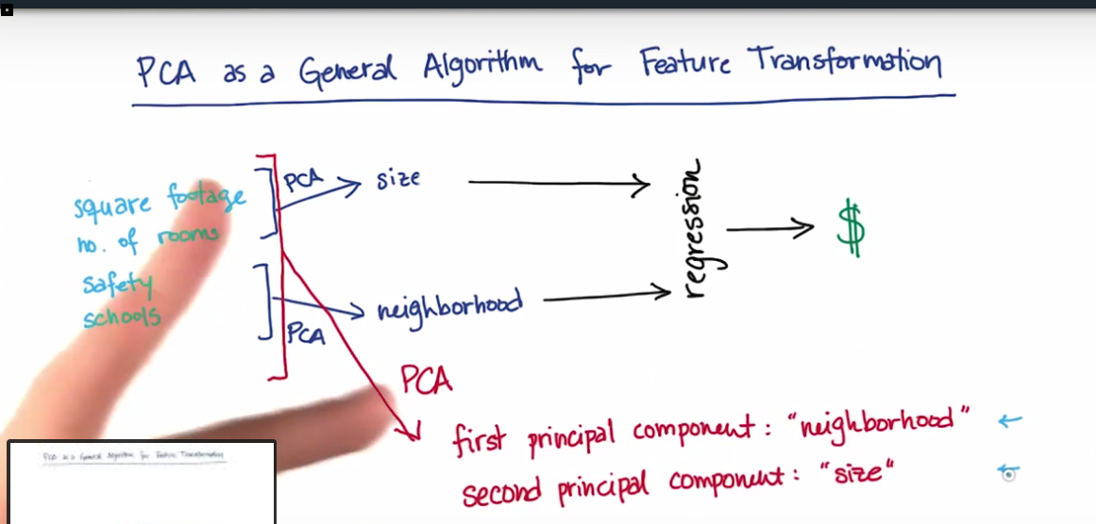

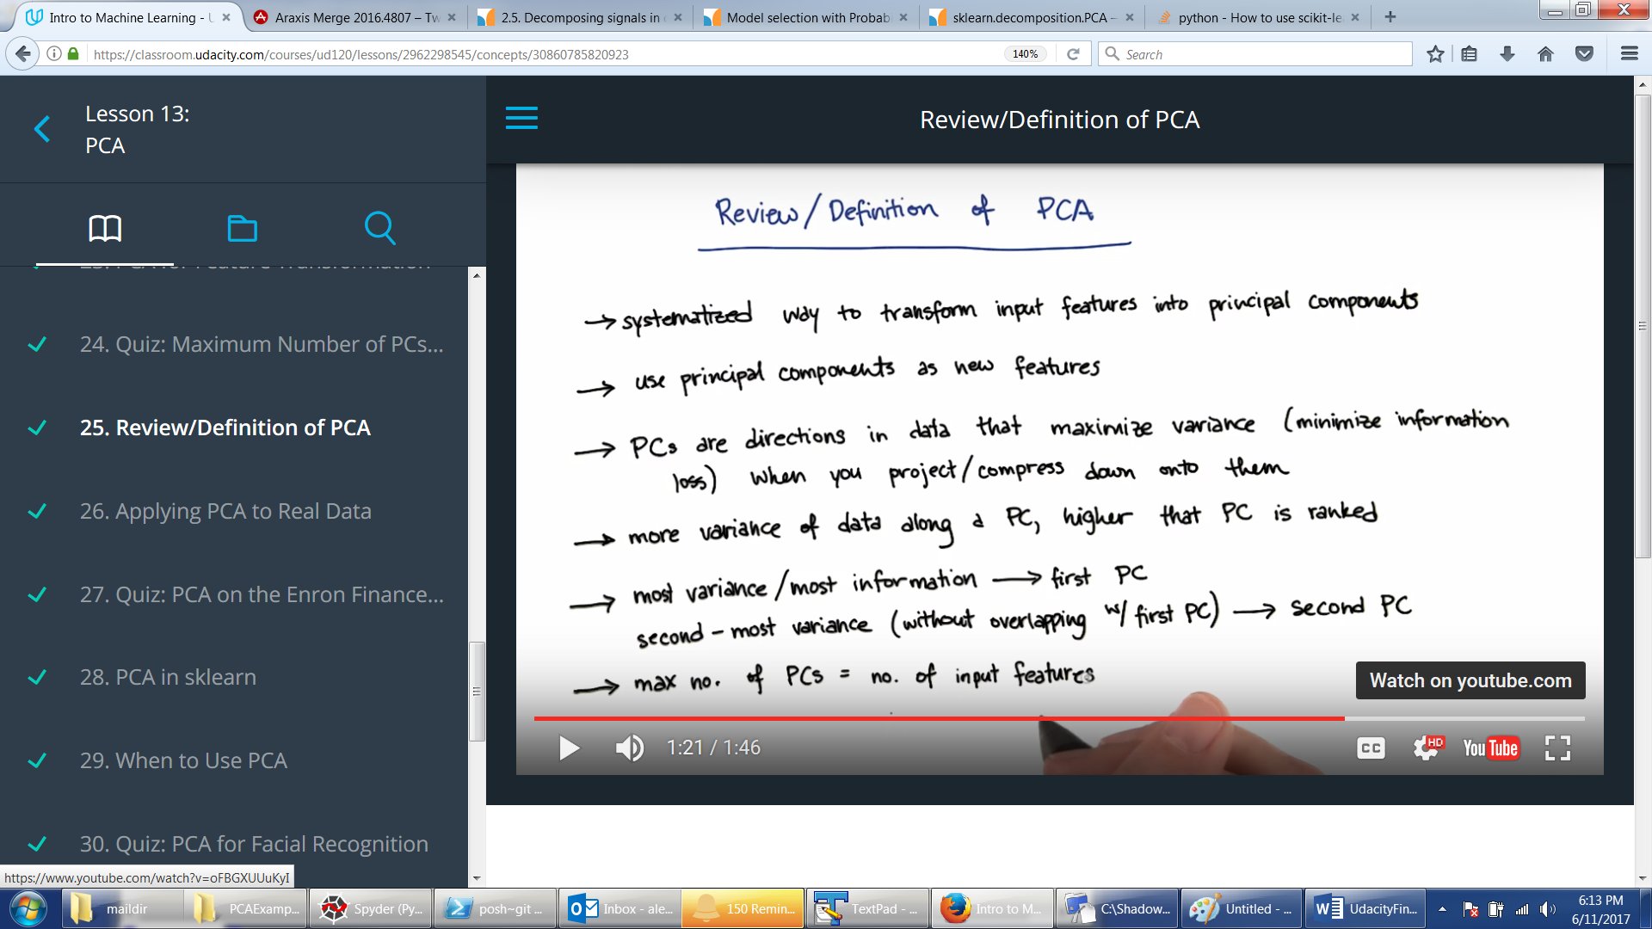

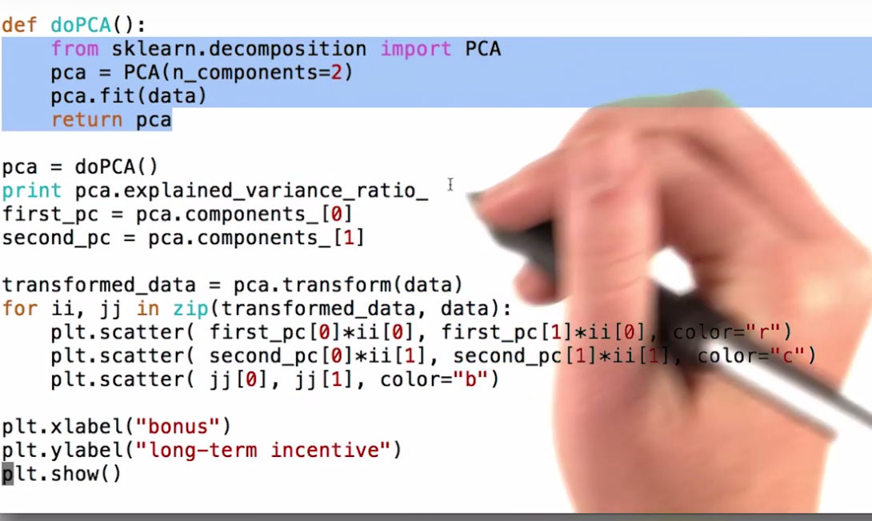

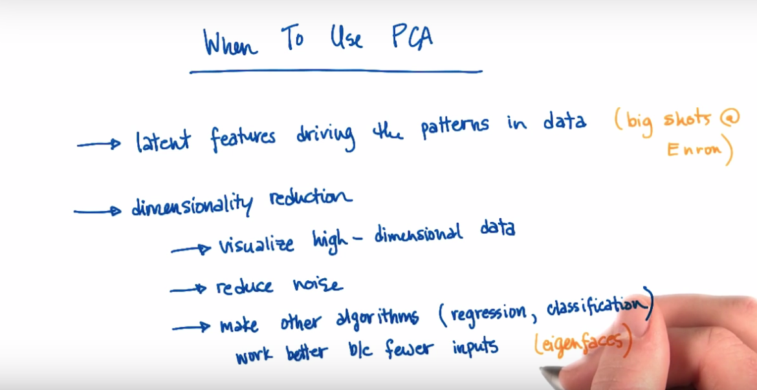

ALgo most likely useful:

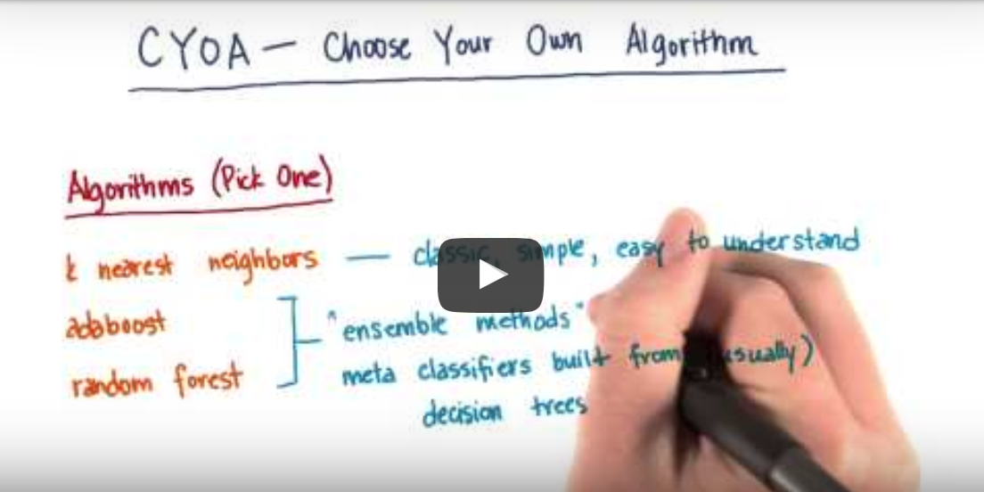

Deep Learning Nanodegree Foundation

Neural Networks.

Important: each node is NOT a function like OR/AND/NAND. Each node is the same function applied to inputs and weight. See my code for Boolean perceptron. The only thing training does is finds values of weights such that

Wx + b is either accepted or rejected.

If singe step function --- is Wx + b >=0 accept else reject.

See my code for linear perceptron.

Linear is not cool because it does not allow for gradual training. You move weights a little but still get 1 – so you don’t know if it was a good move or bad. SO there is continuous function usd 1/1 + e**-x. This brings us to the world of probabilities. Probability is at 50 when Wb+x = 0.

Important training trick: if a point was misclassified the weight are changed slightly to bring the ‘dividing line’ closer to the point. It is done by adding or subtracting xi*learn_rate from wi (se LinearPercetpron.py)

What to do if data is not divisible by line? It is a non-linear regression:

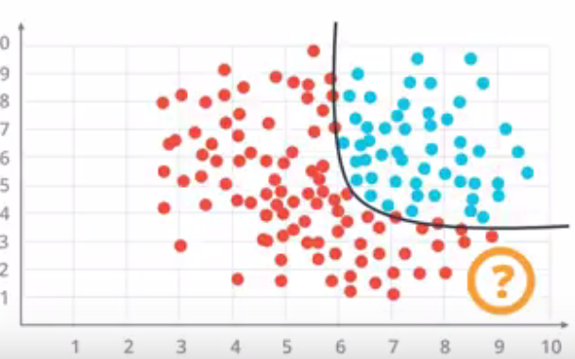

Here instead if easy trick with bringing line closer to point as with linear perceptron we use Log Error function to evaluate how far we are form the point. This function should be continuous and differentiable. This is where the magic is.

Conceptually we are just trying to minimize ERROR when we train where conceptually ERROR is the SUM of distances of all misclassified points form the “dividing line” though it may not be a line at all.

The sigmoid 1/(1+e-x) is not such ERROR function its jus continuous substitute for step_function. At this point Udacity still did not tell me what ERROR calculating function is

Potentially error is CrossEntropy which is SUM(ln(predicted probabilities * prediction)

For example given softmax (see below) lets say our model predicts Prob(pint 1 is red) = 0.8 and Prob (point2 is blue) = 0.9. But then given we got 2 blue points. Our crossentropy then is -ln(0.2) + -ln(0.9)

Minimizing cross-entropy is OUR THING

**Non-binary output.**

Non-binary sigmoid is something that produces not Yes/NO but probability of A is u, probability of B is v, probability of C is w. Given the KNOWN linear model with KNOWN weights. This is something I do not understand. But it is called Softmax (see my code for softmax). The probabilities should sum up to 1. SO they use normalized exponent. Basically here it is: suppose you KNOW a set of outputs (list of numbers> 2). Then run softmax(List) to get probabilities – make sure List is sorted in descending order so list of probabilities is also in descending order.. Then given linear model will produce 1 number and then you run softmax() on this one number and see in what segment it fits – then you predict who it was A, B, or C depending on where that number got in.

For example duck=2, walruss=3, wolf = 5.

Softmax(duck) = exp(2) / (exp(2) + exp(3) + exp(5))

Crazy thing is that Softmax(duck) + softmax(walruss) + softmax(wolf) will sum up to 1.

Another crazy thing is that if we only have two outputs than softmax ~ sigmoid

**Non-numeric input**

Create input variables. For example if inputs are duck, beaver, walrus and we pass duck then use it as 1,0,0. Walrus will be 0,0,1. This is called ***one-hot encoding***

**Maximum Likelihood**

We are getting closer. Seems like the ERROR calc telling us which way to adjust is based on maximizing probability of correct classification….So Maximizing Probability is minimizing ERROR function

This is how it is done: suppose you have KNOWN outputs you are using for training. Take random W vector. And run through sigmoid for each output. For the ones the random model identified correctly leave the probability calculated by sigmoid. For the ones identified incorrectly assign 1-probabilityCalculatedBySigmoid. Now multiplication of all these probabilities is probability P that the MODEL is correct. We want to maximize this. But multiplying is BAD – we use log(P) --- but then we just want to minimize this. Minimize MAGNITUDE of log(P) where P is Product of all probabilities calculated for each point. This log(P) number we are trying to minimize is called Cross-Entropy

Look at crossEntropy.py to see how I coded it for 1/0 binary outputs vs nice vecrtorized thing they did. They did it as SUM(yi * Pi + (1-yi)*(1-Pi)) because depending on Yi either first or second term is 0 so easy to vectorize.

Full formula for ERROR which is indeed a crossentropy is this (averaged by M and with sigmoid substituted for Yhat.

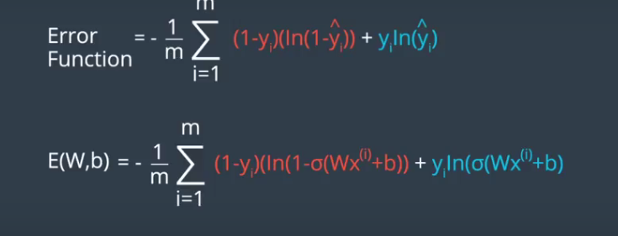

*Now, what if it is multi-class entropy instead of binary entropy*

In this case each point is just sum of

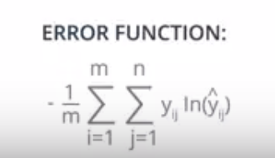

**GRADIENT DESCENT**

See my Jupyter Notebook page GradienDescent. Big point: GradientDescent adjust the separation even for correctly classified points (because in between 0 and 1). Binary perceptron does not adjust for correctly classified point – its just 1. So GradientDescent is better.

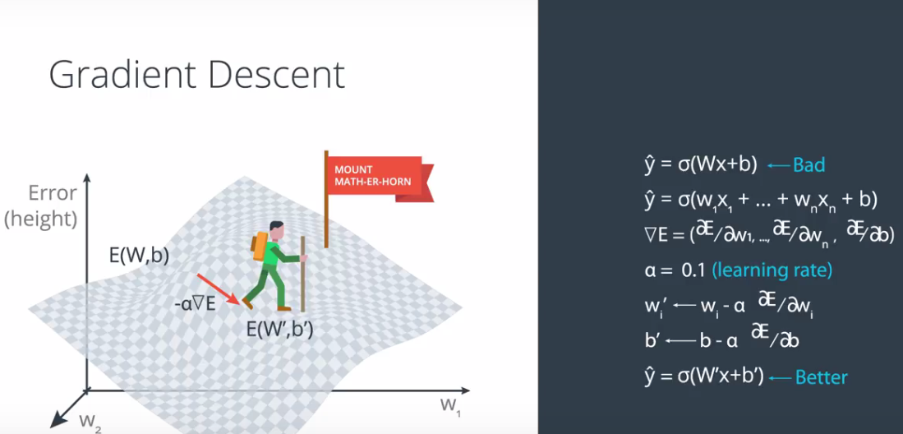

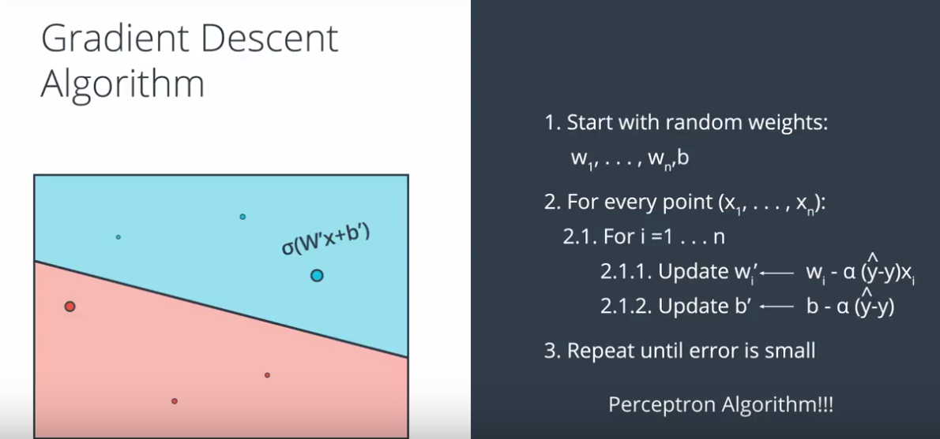

# Gradient Calculation

In the last few videos, we learned that in order to minimize the error function, we need to take some derivatives. So let's get our hands dirty and actually compute the derivative of the error function. The first thing to notice is that the sigmoid function has a really nice derivative. Namely,

σ′(x)=σ(x)(1−σ(x))\sigma'(x) = \sigma(x) (1-\sigma(x))σ′(x)=σ(x)(1−σ(x))

The reason for this is the following, we can calculate it using the quotient formula:

[[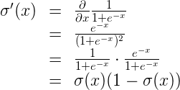](https://classroom.udacity.com/nanodegrees/nd101/parts/73a7fe8e-4354-4362-939d-a8bf2bae870d/modules/e6a4e4a1-98a9-4afe-a744-7ae6a59c01b8/lessons/93d158ce-25e1-4fc1-a187-162982e3cef7/concepts/0d92455b-2fa0-4eb8-ae5d-07c7834b8a56)](https://classroom.udacity.com/nanodegrees/nd101/parts/73a7fe8e-4354-4362-939d-a8bf2bae870d/modules/e6a4e4a1-98a9-4afe-a744-7ae6a59c01b8/lessons/93d158ce-25e1-4fc1-a187-162982e3cef7/concepts/0d92455b-2fa0-4eb8-ae5d-07c7834b8a56)

And now, let's recall that if we have mmm points labelled x(1),x(2),…,x(m),x^{(1)}, x^{(2)}, \ldots, x^{(m)},x(1),x(2),…,x(m), the error formula is:

E=−1m∑i=1m(yiln(yi^)+(1−yi)ln(1−yi^))E = -\frac{1}{m} \sum_{i=1}^m \left( y_i \ln(\hat{y_i}) + (1-y_i) \ln (1-\hat{y_i}) \right)E=−m1​∑i=1m​(yi​ln(yi​^​)+(1−yi​)ln(1−yi​^​))

where the prediction is given by yi^=σ(Wx(i)+b).\hat{y_i} = \sigma(Wx^{(i)} + b).yi​^​=σ(Wx(i)+b).

Our goal is to calculate the gradient of E,E,E, at a point x=(x1,…,xn),x = (x_1, \ldots, x_n),x=(x1​,…,xn​), given by the partial derivatives

∇E=(∂∂w1E,⋯,∂∂wnE,∂∂bE)\nabla E =\left(\frac{\partial}{\partial w_1}E, \cdots, \frac{\partial}{\partial w_n}E, \frac{\partial}{\partial b}E \right)∇E=(∂w1​∂​E,⋯,∂wn​∂​E,∂b∂​E)

To simplify our calculations, we'll actually think of the error that each point produces, and calculate the derivative of this error. The total error, then, is the average of the errors at all the points. The error produced by each point is, simply,

E=−yln(y^)−(1−y)ln(1−y^)E = - y \ln(\hat{y}) - (1-y) \ln (1-\hat{y})E=−yln(y^​)−(1−y)ln(1−y^​)

In order to calculate the derivative of this error with respect to the weights, we'll first calculate ∂∂wjy^.\frac{\partial}{\partial w_j} \hat{y}.∂wj​∂​y^​. Recall that y^=σ(Wx+b),\hat{y} = \sigma(Wx+b),y^​=σ(Wx+b), so:

[[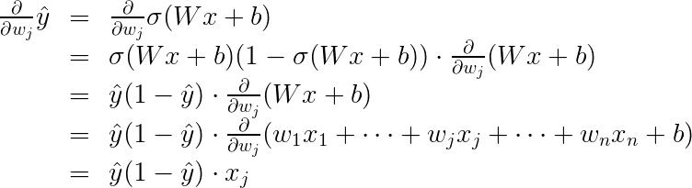](https://classroom.udacity.com/nanodegrees/nd101/parts/73a7fe8e-4354-4362-939d-a8bf2bae870d/modules/e6a4e4a1-98a9-4afe-a744-7ae6a59c01b8/lessons/93d158ce-25e1-4fc1-a187-162982e3cef7/concepts/0d92455b-2fa0-4eb8-ae5d-07c7834b8a56)](https://classroom.udacity.com/nanodegrees/nd101/parts/73a7fe8e-4354-4362-939d-a8bf2bae870d/modules/e6a4e4a1-98a9-4afe-a744-7ae6a59c01b8/lessons/93d158ce-25e1-4fc1-a187-162982e3cef7/concepts/0d92455b-2fa0-4eb8-ae5d-07c7834b8a56)

The last equality is because the only term in the sum which is not a constant with respect to wjw_jwj​ is precisely wjxj,w_j x_j,wj​xj​, which clearly has derivative xj.x_j.xj​.

Now, we can go ahead and calculate the derivative of the error EEE at a point x,x,x, with respect to the weight wj.w_j.wj​.

[[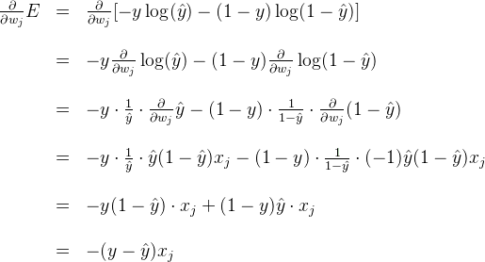](https://classroom.udacity.com/nanodegrees/nd101/parts/73a7fe8e-4354-4362-939d-a8bf2bae870d/modules/e6a4e4a1-98a9-4afe-a744-7ae6a59c01b8/lessons/93d158ce-25e1-4fc1-a187-162982e3cef7/concepts/0d92455b-2fa0-4eb8-ae5d-07c7834b8a56)](https://classroom.udacity.com/nanodegrees/nd101/parts/73a7fe8e-4354-4362-939d-a8bf2bae870d/modules/e6a4e4a1-98a9-4afe-a744-7ae6a59c01b8/lessons/93d158ce-25e1-4fc1-a187-162982e3cef7/concepts/0d92455b-2fa0-4eb8-ae5d-07c7834b8a56)

A similar calculation will show us that

[[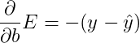](https://classroom.udacity.com/nanodegrees/nd101/parts/73a7fe8e-4354-4362-939d-a8bf2bae870d/modules/e6a4e4a1-98a9-4afe-a744-7ae6a59c01b8/lessons/93d158ce-25e1-4fc1-a187-162982e3cef7/concepts/0d92455b-2fa0-4eb8-ae5d-07c7834b8a56)](https://classroom.udacity.com/nanodegrees/nd101/parts/73a7fe8e-4354-4362-939d-a8bf2bae870d/modules/e6a4e4a1-98a9-4afe-a744-7ae6a59c01b8/lessons/93d158ce-25e1-4fc1-a187-162982e3cef7/concepts/0d92455b-2fa0-4eb8-ae5d-07c7834b8a56)

This actually tells us something very important. For a point with coordinates (x1,…,xn),(x_1, \ldots, x_n),(x1​,…,xn​), label y,y,y, and prediction y^,\hat{y},y^​, the gradient of the error function at that point is (−(y−y^)x1,⋯,−(y−y^)xn,−(y−y^)).\left(-(y - \hat{y})x_1, \cdots, -(y - \hat{y})x_n, -(y - \hat{y}) \right).(−(y−y^​)x1​,⋯,−(y−y^​)xn​,−(y−y^​)). In summary, the gradient is

∇E=−(y−y^)(x1,…,xn,1).\nabla E = -(y - \hat{y}) (x_1, \ldots, x_n, 1).∇E=−(y−y^​)(x1​,…,xn​,1).

If you think about it, this is fascinating. The gradient is actually a scalar times the coordinates of the point! And what is the scalar? Nothing less than a multiple of the difference between the label and the prediction. What significance does this have?

### Quiz Question

What does the scalar we obtained above signify?

* 

• Closer the label to the prediction, smaller the gradient.

• Farther the label from the prediction, larger the gradient.

• 

So, a small gradient means we'll change our coordinates by a little bit, and a large gradient means we'll change our coordinates by a lot.

If this sounds anything like the perceptron algorithm, this is no coincidence! We'll see it in a bit.

# Gradient Descent Step

Therefore, since the gradient descent step simply consists in subtracting a multiple of the gradient of the error function at every point, then this updates the weights in the following way:

wi′←wi−α[−(y−y^)xi],w_i' \leftarrow w_i -\alpha [-(y - \hat{y}) x_i],wi′​←wi​−α[−(y−y^​)xi​],

which is equivalent to

wi′←wi+α(y−y^)xi.w_i' \leftarrow w_i + \alpha (y - \hat{y}) x_i.wi′​←wi​+α(y−y^​)xi​.

Similarly, it updates the bias in the following way:

b′←b+α(y−y^),b' \leftarrow b + \alpha (y - \hat{y}),b′←b+α(y−y^​),

Note: Since we've taken the average of the errors, the term we are adding should be 1m⋅α\frac{1}{m} \cdot \alpham1​⋅α instead of α,\alpha,α, but as α\alphaα is a constant, then in order to simplify calculations, we'll just take 1m⋅α\frac{1}{m} \cdot \alpham1​⋅α to be our learning rate, and abuse the notation by just calling it α.\alpha.α.

**But what if it is not a line separatable data**

For data like this we create probability function but plotting points that are equally likely to be on one side or the other:

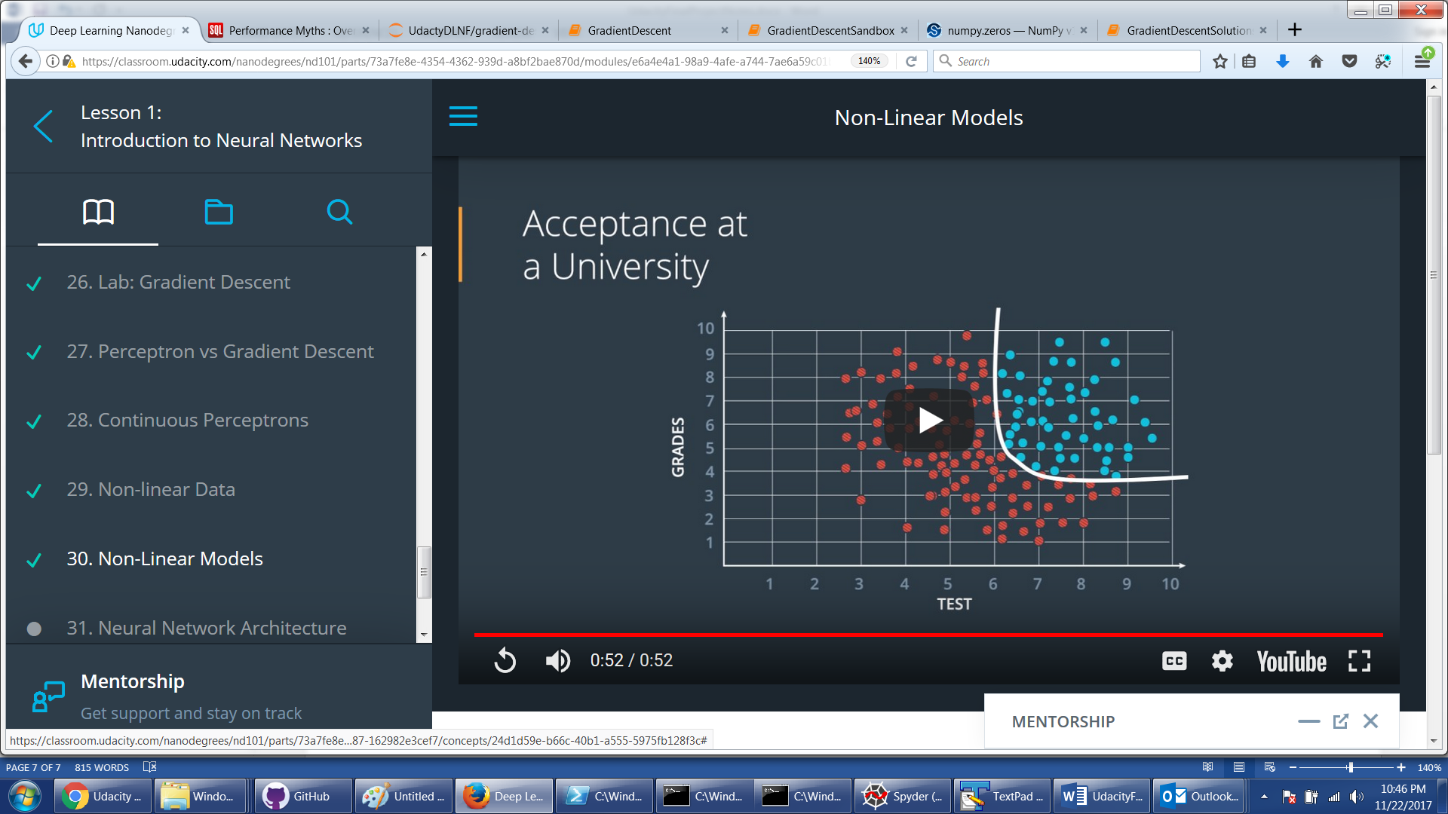

So the way to get that curve is to “combine” two lines. See leftmost layer in below picture.

But the trick is that “combining” means apply Sigmoid(Sigmoid(model1) * weight1 + Sigmoid(model2)* weight2). Picture below show is – and it becomes nothing more than the same perceptron with trainable weights. The only thing picture below does not explain is how we came up with 2 nodes in first hidden (hidden means non-input and non-utput) layer and one node in second layer. I am guessing 2 comes from the fact that we are looking at 2-dimensioanl space: red or blue. We will see…actually NOT. Section 31 video in DLNF Lesson 1 is a revelation

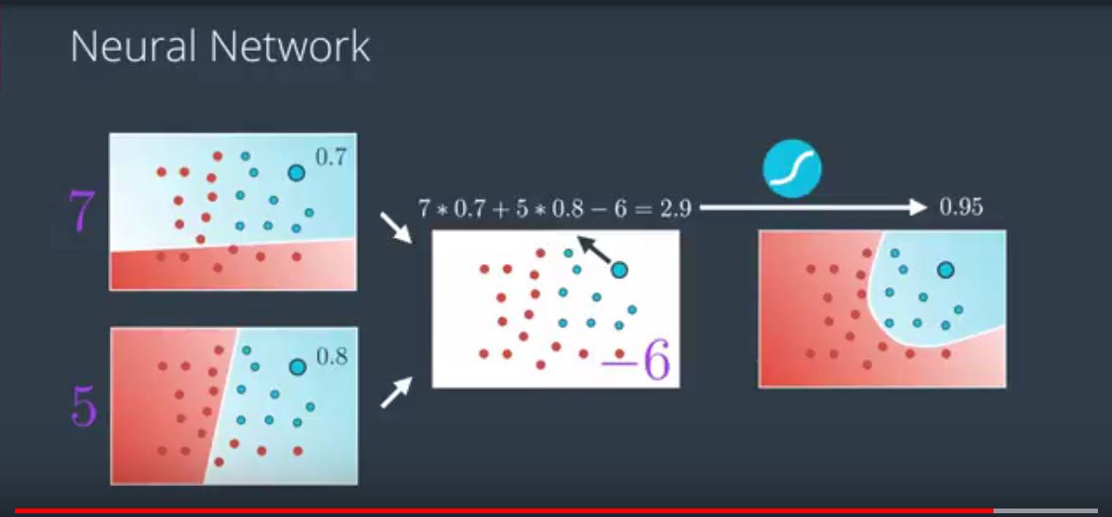

The actual data preparation for Gradient Descent Neural Network

* Need to normalize all inputs do that they have zero mean and a standard deviation of 1. This is because of nature of sigmoid function. It squashes really small and really large inputs. The gradient of really small and large inputs is zero, which means that the gradient descent step will go to zero too. See data_prep.py
* Initial weight initialization requires interesting approach:  
  We want these to be small such that the input to the sigmoid is in the linear region near 0 and not squashed at the high and low ends. It's also important to initialize them randomly so that they all have different starting values and diverge, breaking symmetry. So, we'll initialize the weights from a normal distribution centered at 0. A good value for the scale is 1/√​n​​​ where n is the number of input units. This keeps the input to the sigmoid low for increasing numbers of input units.

weights = np.random.normal(scale=1/n_features**.5, size=n_features)

* Also see my GDNeuralNework 1 – one layer.

**Backpropagation**

Important is to understand that we are trying to calculate delta_w on each layer by propagating back the WEIGHTED error.

Lesson 2 backpropagation exercises and especial a description of 2 input -> one hidden -> One output network is priceless. Also my code for backpropStepForAdmissions is priceless with comments.

Testing - underfitting vs overfitting.

General idea is to overfit but use techniques that roll back effects of overfitting. This is done by looking at accuracy of model on training set and on testing set and finding the Golden Spot where there is a good fit on training and testing together. Because the further in terms of number of epochs we go the worse we do on testing set because of overfitting. SO stop in the right epoch ☺

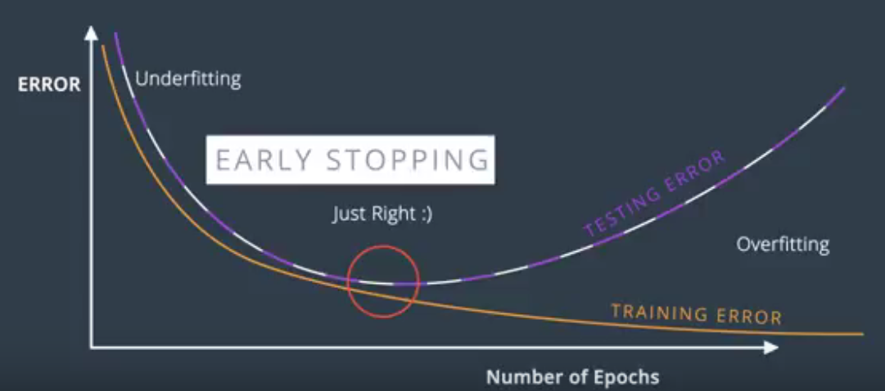

Another trick to prevent overfitting is Regularization. There are 2 kinds L1 and L2. Both just add a term to error function to make the large weights less “intrusive” – basically penalizing large weight. This is because large weights make the model to easily overfit.

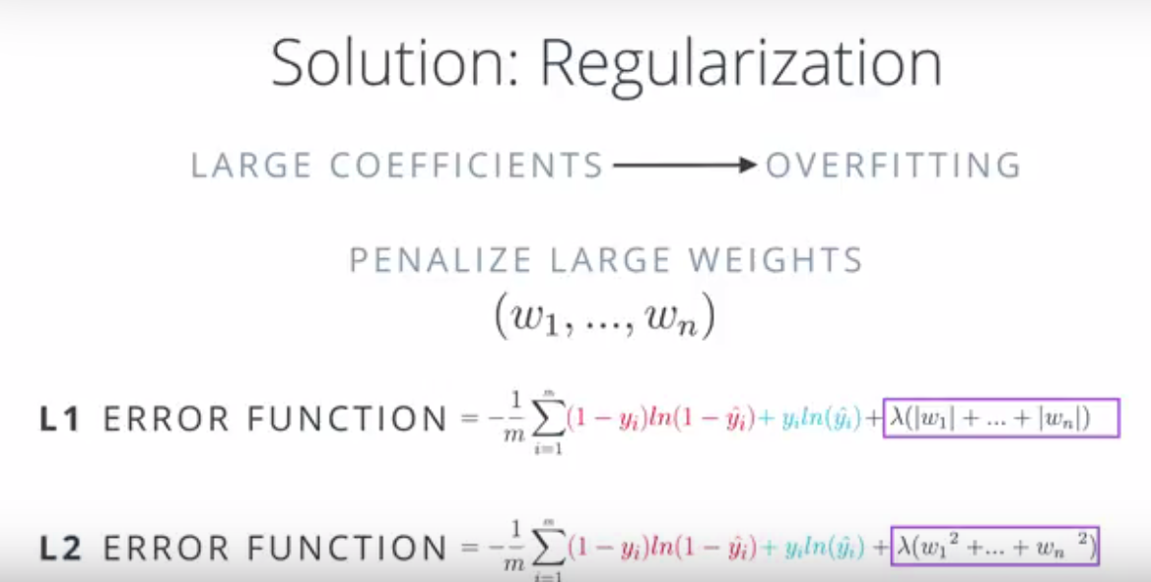

L1 is good for feature selection because it moves some weights to 0 quickly thus getting rid of unimportant features. The L2 is good for training models.

Another cool method for training is turning OFF nodes with probability P form each EPOCH. Its called DROPOUT

To solve the problem with Vanishing Gradient we can use tanh or ReLU. The problem with sigmoid is that derivatives go to 0 really quick and chain rules multiplies derivatives. SO tanh or even ReLU tha is linear solves this problem easy.

Stochastic Gradient Descent is doing the whole forward and back propagation N times with small batches of data of size Size/N rather than one time with whole data. This is because N small steps are computationally less intensive than 1 large step. MEMORY for Matrix Multiplication is an issue

Learning rate decay is a schema that allows to take large gradient descent steps when the error is alrge and smaller ones when it is small. This is very cool.

The way to deal with local minima is random restart with random initial weights!!!!! Just like your simulated annealing

Also concept of Momentum is something that helps with local minima. Because the random restart is computationally expensive

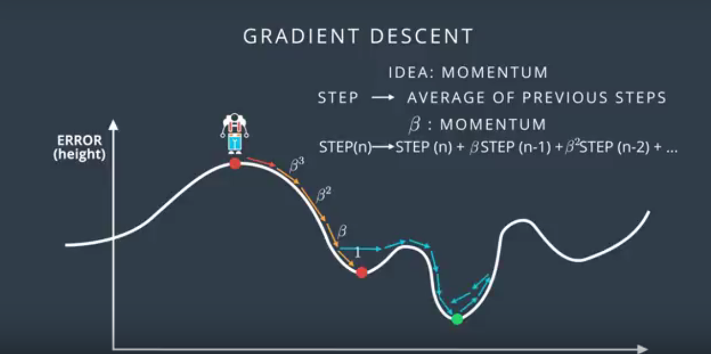

# Evaluating How Good the Neural Network IS

1. Confusion Matrix: simply

[[TruePositive, FalseNegative],

[FalsePositive, TrueNegative]]

1. Accuracy: simply correct/total – not good when small number of things to identify then if you miss them all it still could be 99% accuracy
2. Precision = TruePositive / (TruePositive + FalsePositive) we want high precision if we want to Err on the side where we really do not want False Positives and much rather have more False Negative  
   Recall = TruePositive / (TruePositive + FalseNegative) we want highr ecall where we really do not want False Negatives and much rather have more False Positives

# Linear Regression

1. Build a line.
2. Minimize error by using gradient descent to minimize either absolute error 1/m(SUM|y – y_h|) or by minimizing squares 1/2m(SUM((y – y_h)**2))
3. Squares are better because more tending to go to middle – with absolute the error does not change if line just moves up or down.
4. Use sklearn to fit.
5. Multi-variable is still OK.
6. Polynomial is still OK but complex
7. Has CLosedForm solution where we could just compute weights minimizing the Error but it is very expensive.
8. Regularizaion!!! – is a trick that lets us chose simpler model instead of more complex. For example Linear instead of polynomial. This is done by penalizing –increasing error based on number of polynomial coefficients. So model pays price if it tries to be more complex. Tehre is L1 or L2 regularization – difference is adding abs(coefficient) or square(coefficient). Introducing coefficient LAMBDA les us control how much we penalize. For example small LAMDA means penalize complexity a little bit. And vice versa.

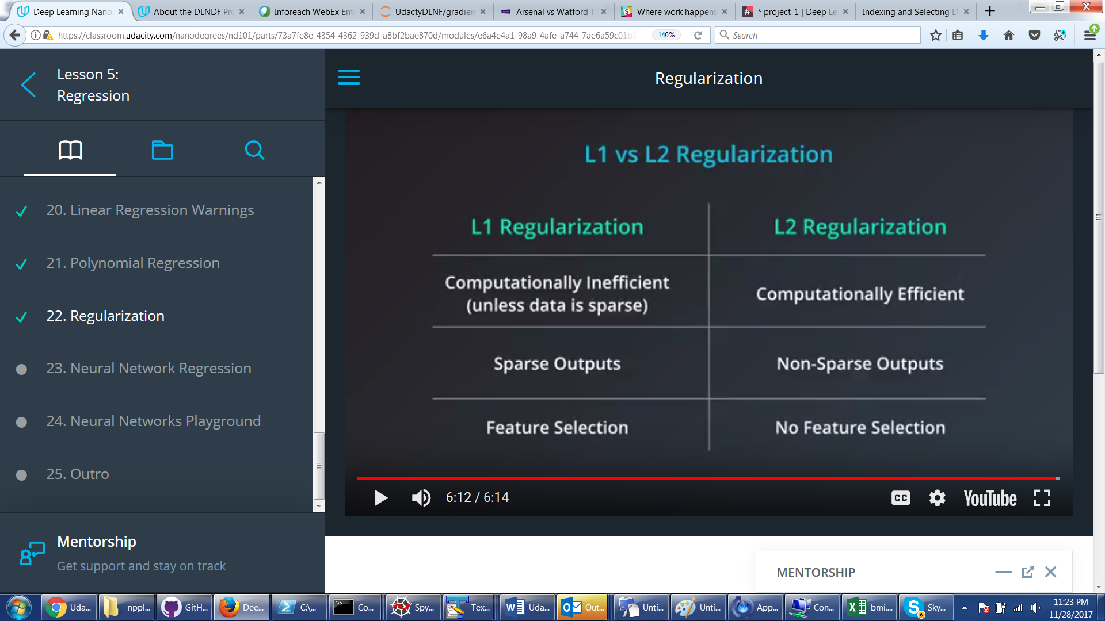

The coolest thing is that Neural Networks can be used to find weights for Linear Regression – each layer is a line segment form pic below. Only difference is that we are removing sigmoid from the last node and replacing it with just the value and then trying to minimize linear regression error (absolute or square). And this just works with back propagation etc…!!!!!!!!!

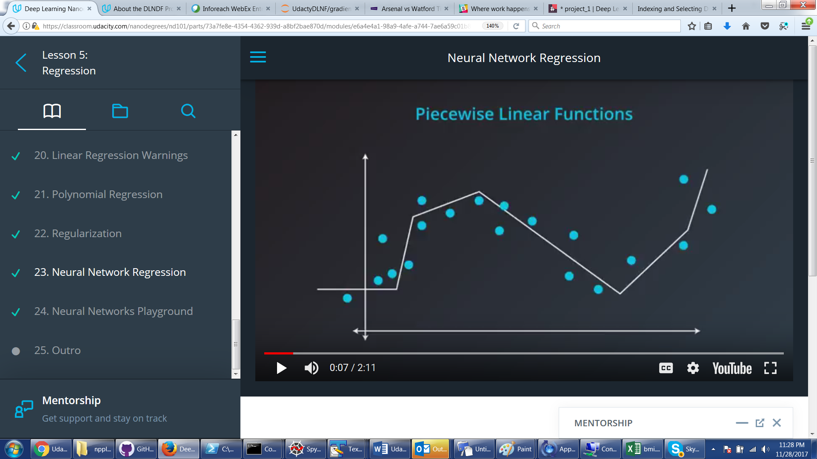

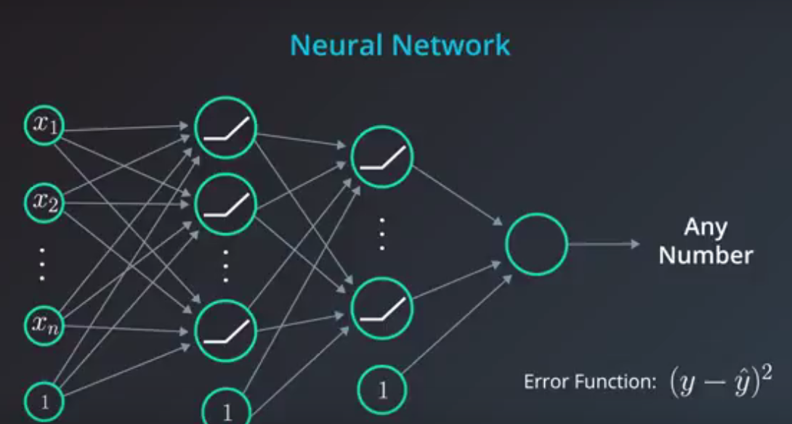

Visual playground for using NN for Linear regression

<http://jalammar.github.io/visual-interactive-guide-basics-neural-networks/>

# Sentiment Neural Network Lesson (NLP movie review)

Highly cool. Very important – data curation. How to represent data so it provides most signal and least noise to the network.

Cool trick on positive_to_neagtive ratio for each word.

Look at 3 of my SentimentNN python files. One does it straight up – each work is translated to number of occurrences – bad because dumb words overeweigh. Then just Yes or No if occurred – better but slow. But with Yes/NO which are just 0/1 we were able to get rid of a lot of computation – just add Weight vectors. I guess this was the trick of why NOT to use any sigmoid on hidden layer. Computational speed. And then we actually did reduce number of words even more by only doing those that have high positive_negative ratio amplitude. Sped up network 7 times. Lost only 3% of precision.

Finally, coolest trick – he showed how NN assigned similar weights to words we humans know are similar!!!

# KERAS

Watch my Keras project code. Highly cool

# TensorFLow

Watch my TensorFlow project code. Tf.py contains small tricks and building blocks.

For more examples have to look here:

<https://github.com/aymericdamien/TensorFlow-Examples>

But most important thing is to remember that most of the code is abstract linking of things into final tensor and then passing this final tensor to Session too run

How to play with Hyperparameters:

<https://machinelearningmastery.com/grid-search-hyperparameters-deep-learning-models-python-keras/>

# Convolutional Networks

NOTE: the whole set of lesson videos is basically priceless. Must save it

Not fully connected – could be locally connected layers. Saves computations

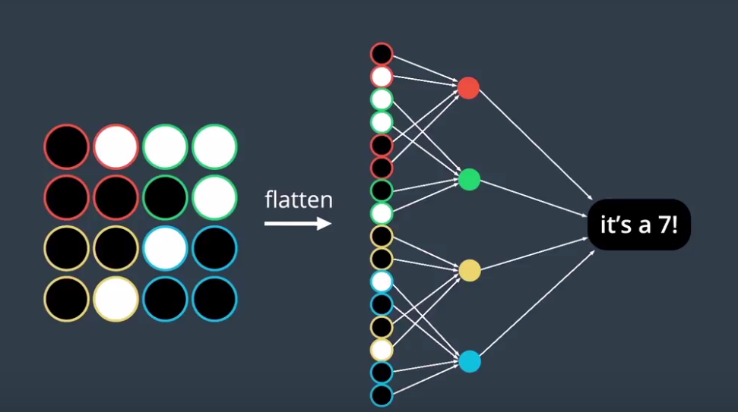

And could have more layers but still locally connected

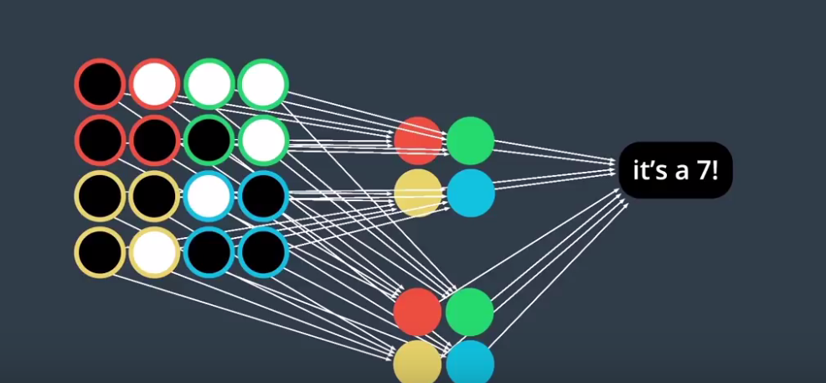

So the idea is that simple images are ok with MLP (MultiLayerPerceptrons). Bu we don’t know where in the image the “meat” is so have to come up with researching each region separately.

Imagine is region as a Window. Sliding one (or more) pixels right and down. This is what the cool idea is. On each slide most of the weights are shared thus taking into consideration the fact that in close square regions info is important. Each sliding window is node in convolutional layer. Each set of weights leading to convolutional node is a Filter that can be represented as a matrix:

So idea of CNN – do convolutional layers with sliding windows trained for edge patterns

DO it for each RGB layer. Use Pooling layers to reduce the whole thing to simple conceptual Yes/Nos on the “patterns”, e.g. has wheels? Yes, and at the end put it into regular MLP for training…!!!!

CIfar Winner did 95%

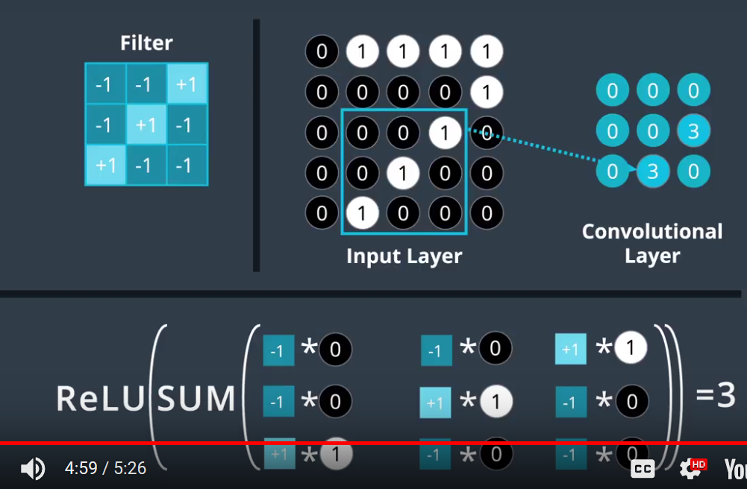

Pooling layers are very important. MaxPooling for example reduced each 3x3 quadrant to 1x1 quadrant (max)

GlobalPooling reduces to average – basically makes everything 1-demisnional. Interestingly, GlobalPooling works better than Flatten. I found out biased on my experimentation with ResNe dog breeding network. My network did 83%:

from keras.layers import Conv2D, MaxPooling2D, GlobalAveragePooling2D

from keras.layers import Dropout, Flatten, Dense

from keras.models import Sequential

ResNet_model = Sequential()

ResNet_model.add(GlobalAveragePooling2D(input_shape=train_ResNet.shape[1:]))

#ResNet_model.add(Dropout(0.2))

#ResNet_model.add(MaxPooling2D(pool_size=2, input_shape=train_ResNet.shape[1:]))

#ResNet_model.add(Flatten())

ResNet_model.add(Dense(1024, activation='tanh'))

ResNet_model.add(Dropout(0.4))

ResNet_model.add(Dense(512, activation='tanh'))

ResNet_model.add(Dropout(0.4))

ResNet_model.add(Dense(133, activation='softmax'))

#ResNet_model.summary()

ResNet_model.compile(loss='categorical_crossentropy', optimizer='rmsprop', metrics=['accuracy'])

There is also a concept of “augmentation”. Basically train on duplicates of the same picture only rotated or skewed or shifted.

Cool thing: AutoEncoders. Conv Network that reduces images (compresses) folloed by reverse conv layers that increase images (decompress). Highly cool stuff – can get rid of noise even though it it ‘lossy’

Also unintuitive: training cancer –recognizing network on images of dogs and cats actually made predictions better.!!!!

# RNN – Recurrent Neural Networks

Idea is that into each node we pass an input and output from previous – capturing ‘temporal” dependencies. S is state – stored memory:

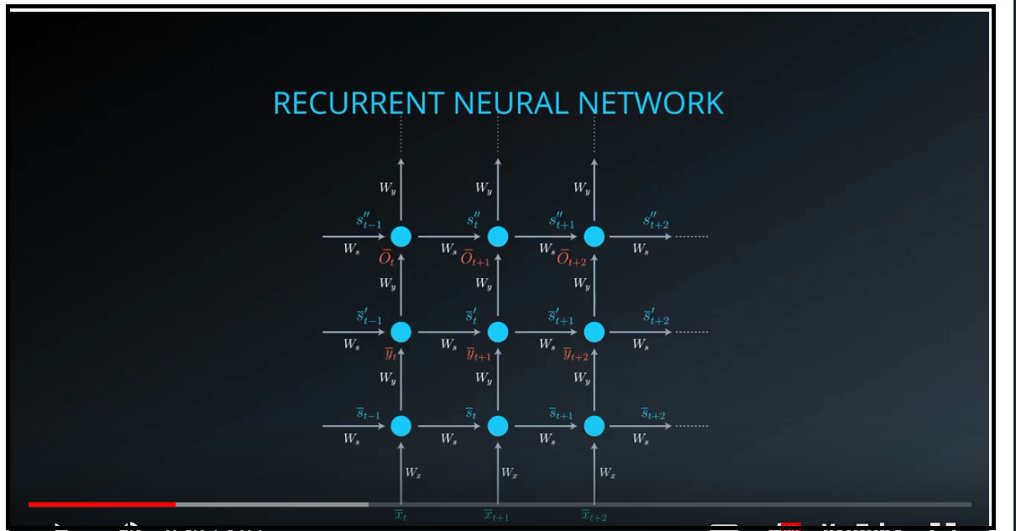

Important: with RNNs we don’t pass inut to get output RNNs are trined in sequences with previous inputs. **Current inputs as well as activations serve as inputs to next time step**

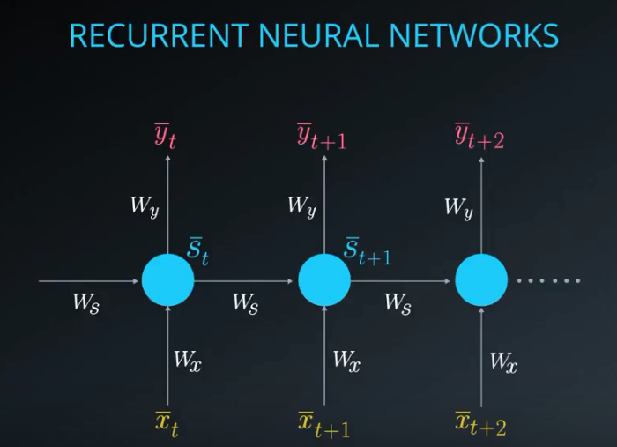

Conceptually the out put of a hidden layer serves as inout to next training step (purple). Below is simple RNN – Elman network.

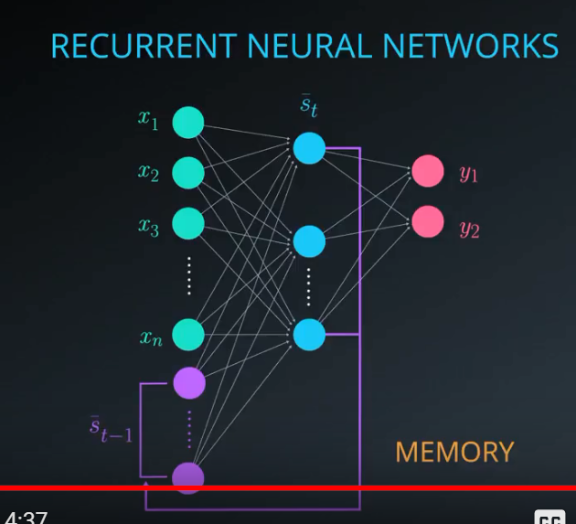

Folded model: one concept neuron:

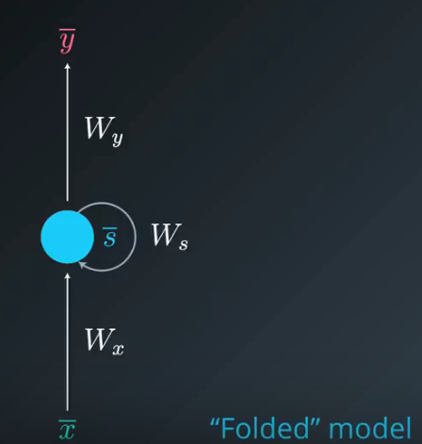

Unfolded: 3d screenshot from here UP.

Important MATH:

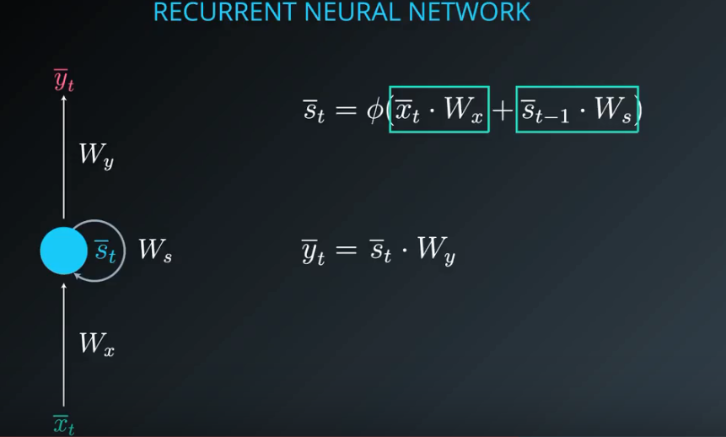

LSTM – each neuron has weights and functions to rememebre/forget/learn some things from previous inputs. Highly cool:

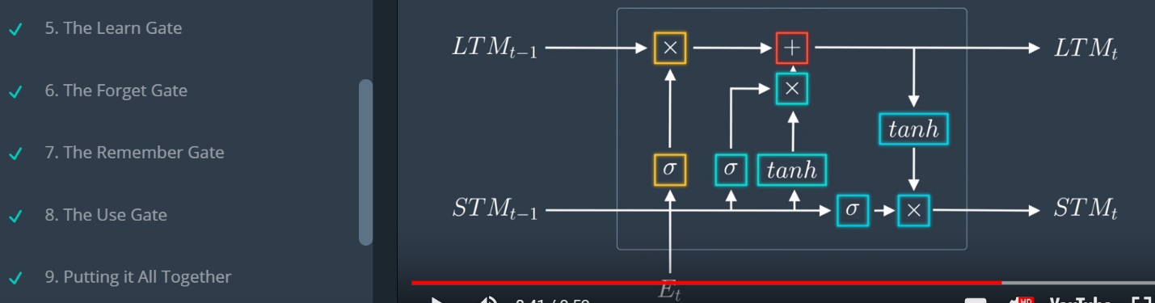

Highly suggested HYPERPARAMETERS:

3-4 layers. LR of 0.1, 0.01, 0.001

Word2Vec embedding – the coolest thing. Train the network to represent each word as a vector of numbers (lets say 300 numbers). This is instead of one-hotting each word out of 100000 vocabulary words. Then each “similar” vector should logically be found in “similar” contexts. This is based on linguistics work done in 50s.

See <http://mccormickml.com/2016/04/19/word2vec-tutorial-the-skip-gram-model/>

The RNN solutions with more or less readbale TF examples is in my DLNF project3 folder

# GANs – Generative Adversarial Networks

The coolest thing ever. These ones “predict the future”. For example, show picture of birds --- predict new unknown bird.

The greatest thing here is that these can be unsupervised. Show picture of faces and cartoons – it will learn to turn a picture of face into carton. An outline drawing can be turned into real landscape painting. Or horse in Wyoming into Zebra in Africa. See GANs examples on Youtube

Adversarial seems to refer to the fact that it can learn to ignore deliberate attempts and misdirection in images. NO. There is a Generator and Discriminator. Generator generates images and discriminator learns to assign real or fake labels to them. Eventually generator learns to generate “real” images. That’s why it is “adversarial”. Believe it or not this competition is based on Game Theory.

# What is Batch Normalization?

Batch normalization was introduced in Sergey Ioffe's and Christian Szegedy's 2015 paper [Batch Normalization: Accelerating Deep Network Training by Reducing Internal Covariate Shift](https://arxiv.org/pdf/1502.03167.pdf). The idea is that, instead of just normalizing the inputs to the network, we normalize the inputs to layers within the network. It's called "batch" normalization because during training, we normalize each layer's inputs by using the mean and variance of the values in the current mini-batch.

Why might this help? Well, we know that normalizing the inputs to a network helps the network learn. But a network is a series of layers, where the output of one layer becomes the input to another. That means we can think of any layer in a neural network as the first layer of a smaller network.

Very important page about batch normalization. In general this regularization and hyper parameters thing is so important that this may be where the ‘salt’ is – need to study as much because this is were my added value will be.

<http://localhost:8888/notebooks/DLNF/deep-learning/batch-norm/Batch_Normalization_Lesson.ipynb#theory>

It will overcome ‘somewhat bad’ starting weights –so cool. But if starting weighs are not good AND lerarning rate is not good then nothing helps.